Clinical Reasoning: BN604002 Mental Health and Addictions

Nursing Practice Care Plan

Name (verbal consent from individual Privacy Act 2020, pseudonym):

Age (Approximately):

Date of admission (to community/rest home, ward) presentation:

Legal Status (Voluntary or relevant Law or Act):

Ethnicity:
Culture:
First language preference:
Pronoun preference:
Vision/hearing impairment:
Alternate form of communication:

Client’s reason(s) for admission/presentation:
(What does client say& what do carers/staff say?)

Client’s expectations of admission:

Brief Interdisciplinary team expectations/care plan:

Previous relevant hospital admissions:

Assessment using Te Whare Tapa Whā, (Durie, 1994):

Complete the brief assessment below:

A. Taha Tinana (physical health)

Heart rate:
Blood pressure:
Temperature:
Respiration (rate, pattern):

Body system/s name (2) two systems most impaired and assess:
(e.g.: endocrine, respiratory, cardiac & CNS etc.)

Common and long term/chronic conditions your client may have:
(Consider metabolic syndrome, diabetes, cardiovascular and respiratory disease, mental health related physical conditions).

Pain/discomfort:
(Consider both physical and psychological, past, and now).

B. Taha wairua (spiritual health)
(Brief assessment).

Valuing: (sense of purpose, meaning, inner strength, capacity for change, self-acceptance)

Strengths and coping skills: (personal strengths and resources)

Cultural/spiritual attitudes/beliefs & values:

C. Taha whānau (family health)
(Brief assessment).

Early development: (Birth, Plunket books for early development history, Milestones, Education history, literacy & numeracy).

Whanau/Family background: (Whanau/family & iwi/whakapapa/significant stories including physical/medical history, mental health history, important stories, genogram/whanau family tree).

Social relationships: (employment, whanau, children, parents, partners, sports/interest groups).

- Taha hinengaro (mental health) The capacity to communicate, to think and to feel mind and body are inseparable (comprehensive mental state & risk/safety assessment)

Appearance:
(Consider age & stage and weather & environs)

Behaviour/Motor activity:
(Pacing, agitated, slowed, catatonic)

Speech and Thought Processes: (volume, rate, quantity, quality)

Mood: (Subjective: How the person says they feel. Consider sleeping patterns: (insomnia, quality, sleep aids), diet, hobbies and sport, ADL’s, level of motivation).

Affect: (Objective: How you think they look? Congruent/Incongruent mood & affect. Is affect blunted, flat, restricted, labile).

Perceptions: (auditory, visual, tactile, olfactory hallucinations, illusions, depersonalisation, derealisation)

Thinking Process: (The pattern of a patient's speech allows the examiner to note the quality of the thought process, including its flow, logic, and associations. Abnormalities of the thinking process can include loose association, tangential thinking, flight of ideas & circumstantiality).

Thought Content:
(What the person is thinking, ruminations, obsessions, compulsion, homicidal/suicidal thoughts, delusions. Start to consider risk).

CNS: (Head injuries, knocked out, concussion, neurological changes &/or symptoms)

Orientation: (Can individual explain: Person, Place, Time).

Memory: (intact, short term, long term, provide examples).

Judgement: (intact, age appropriate, impaired).

Insight: (Do they understand or believe they are unwell?

Alcohol and other drugs:

Use the ASSIST Lite: Alcohol, Smoking and Substance Involvement Screening Test for your client please.

Brief intervention, assessment tool about the use of psychoactive substance use in the last 3 MONTHS.

For Tobacco, Alcohol, Cannabis, Amphetamine-type stimulants, non-prescribed & prescribed sedatives, sleeping tablets, opioid (street & prescribed) and any other psychoactive substances.

If moderate/high use in last 3 months &/or longer than discuss with RN Preceptor re further referrals to AOD treatment and support.

https://eassist.assistportal.com.au/#/eassist-lite

Gambling: Yes No

Historical &/or current? Referral?

Alcohol & Other Drugs Assessment: A paragraph with summary of assessment for your individual (input here):

RISK & RISK FACTORS:

RISK: (Can include risk of suicide, accidental and intentional overdose of alcohol and other drugs, financial, emotional, and sexual exploitation, vulnerability from others).

Harm to Self: Self harm, Isolation, Alcohol and drug abuse/dependency, command or degradatory hallucinations, Exploitation from others, financially, sexually, socially impulsive & paranoid delusions (false fixed beliefs) that leave individuals at risk.

Harm to others: Family violence, Alcohol, and drug abuse/dependency, command or degradatory hallucinations instructing violence, risk taking involving others. Exploitation from others, financially, sexually, socially impulsive & paranoid delusions (false fixed beliefs) that leave individuals at risk.

You are to assess the risk of the person you are caring for use the Columbia Suicide Severity Rating Scale (C-SSRS) and the information.

Please include in your assessment:

- Strengths/Protective Factors.
- Long term (Static/Past/Historical) risk factors including,
  - suicidal behaviour,
  - impulsivity (arson, self-control issues, poor emotional regulation, and coping skills) Alcohol & other drugs abuse or dependency.
  - Physical harm/violence and aggression to others.
- Recent/dynamic/present suicidal ideation/plan and its lethality.
- Recent self-harm and suicidal behaviour.
- Physical harm/violence and aggression to others.
- Recent changes in symptoms and illness state.
- Ability to have insight into illness, distress, impairment of judgement.

Harm to Self: Self harm, Isolation, Alcohol and drug abuse/dependency, command or derogatory hallucinations, Exploitation from others, financially, sexually, socially impulsive & paranoid delusions (false fixed beliefs) that leave individuals at risk.

Risk Assessment (input here):

In this section you will need to process the information you have collected from your assessment using the Clinical Reasoning Cycle, (Levett-Jones, 2022):
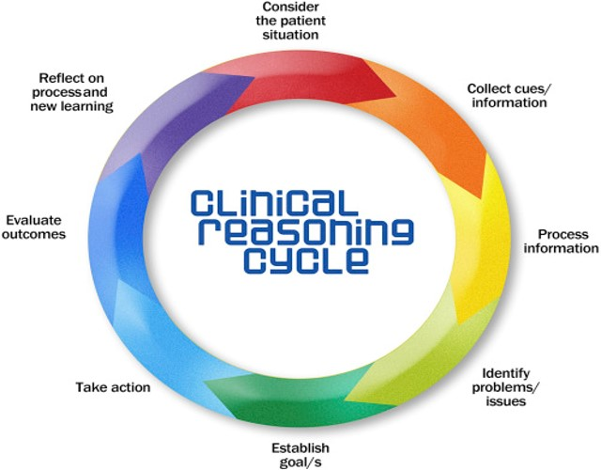

Identify one safety/risk /issue that focuses on the individual’s mental health, and establish goal: (from the above clearly identify one with interventions, rationale, and evaluation of the chosen approach to care)

- Nursing Issue (related to mental health and or addictions risk factor)
- Goal
- Interventions or Plan
- Rationale/Why?
- Evaluation: (what worked well, what didn’t work well, what would you change?)

Linking Theory to Practice (using appropriate literature, reference, and research the following to show the process of linking theory to practice with your chosen client)

Provide the following information in relation to your client.
Include:
A brief overview of diagnosis, (referenced) and how this relates to your client.

Psychiatric medications include the following and how they relate to your client:
mechanism of action, indications for use side effects, contraindications, client education.

References:

Durie, M. (1994). Whaiora: Māori health development, (2nd ed.) Oxford University Press New Zealand: Oxford, UK.

Foster, F., Marks, P., O’Brien, A. & Raeburn, T. (2021). Mental Health in Nursing: Theory and practice for clinical settings, (5th ed). Elsevier
Australia.

Levett-Jones, T. (2022). Clinical reasoning: Learning to think like a nurse (3rd ed.). Pearsons: Australia.

Pisani, A.R., Murrie, D. C., & Silverman, M. M. (2016). Reformulating Suicide Risk Formulation: From Prediction to Prevention. Acad Psychiatry, (40), 623-629. DOI 10.1007/s40596-015-0434-6.

University of Adelaide. (2023). ASSIST Lite: Alcohol, Smoking and Substance Involvement Screening Test. Assist Portal
https://assistportal.com.au/recsources/

