**BN601002 Clinical Reasoning: With Focus on Community Context**

**Student Name & Student ID:** ________________________________________________

**Placement Dates:** _________________________________________________________

**Placement Location:** ______________________________________________________

**Parts one and two are written, part three is an oral discussion**

**Part One. Describe your clients - the population in the middle of the community assessment wheel.**

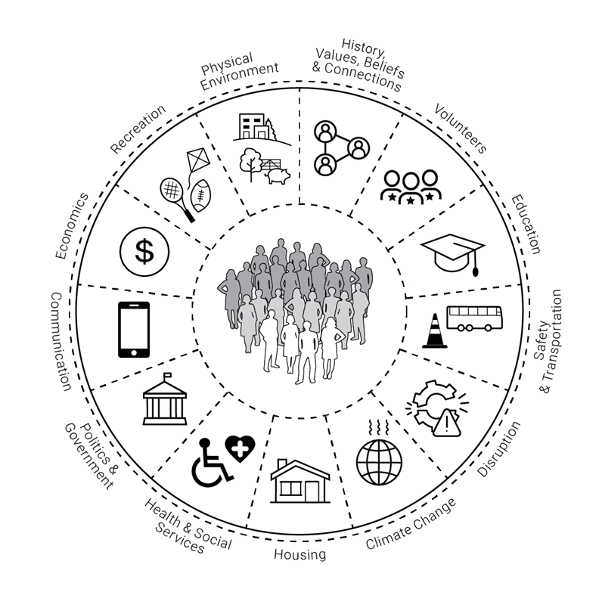

Figure 1 Community Assessment Wheel adapted version by Ross (2025). Original Community as partner wheel by Anderson & McFarlane (2011)

Describe your client population:

Discuss with preceptor using census and health statistics as appropriate.

1. ages
2. ethnicities
3. income range/employment
4. education
5. access to internet
6. key health challenges
7. What client groups may be vulnerable? (The 11-wheel segments may help you brain storm these).

**Part Two. Your placement is one of the services resourcing your population. Tell us about your placement’s health response to its client population**:

1. describe the rural/urban nature of the placement and what are the service’s geographical boundaries?
2. how is the service funded?
3. what services are offered?
4. how can clients access service?
5. costs/fees for clients?
6. list health and social organisations/services your organisation works closely with.
7. describe at least two strategies your placement employs to reduce inequities in health outcomes

**Part Three**. **Verbal Discussion with Kaiako: Choose one client or population/community within your client base. Incorporating your learning from parts 1 & 2, work through the clinical reasoning cycle (Levett-Jones, 2023, p. 6), preparing to discuss this in detail with your clinical supervisor (Kaiako) in week 2**.

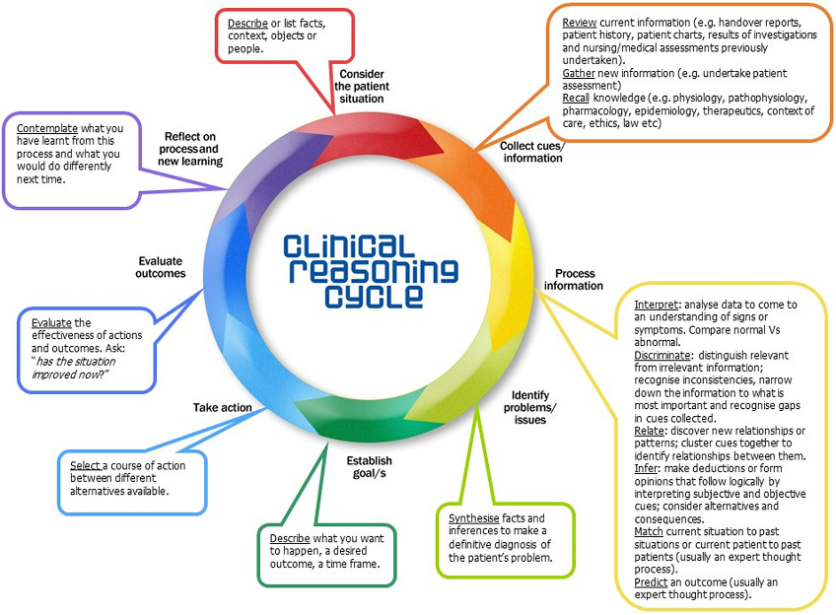

*Figure 2. Levette-Jones (2023, Fig 1.2, pg 6)*

Levett-Jones, T. (Ed.). (2023). *Clinical reasoning: Learning to think like a nurse* (3rd ed.). Pearson Australia Group LTD. ISBN: 9780655703990.