# A blue rectangle with white text Description automatically generatedBN704002 Y3 Mental Health and Addictions

# Nursing Practice Care Plan

**Name (pseudonym): Age:**

**Date of admission / presentation: Date care plan commenced:**

**Legal Status (Voluntary or relevant Law or Act):**

**Risk management plan: Yes No**

(Only Used in Dunedin MH Services, Te Whatu Ora)

Ethnicity:

First language preference:

Pronoun preference:

Vision/hearing impairment:

Alternate form of communication:

**Brief client’s reason(s) for admission/presentation**:

(What does client say?)

**Brief client’s expectations of admission**:

**Brief Interdisciplinary team expectations/care plan:**

**Previous relevant hospital admissions**:

**Assessment using Te Whare Tapa Whā, (Durie, 1994):**

Complete the brief assessment below:

**A. Taha Tinana *(physical health)***

Heart rate:

Blood pressure:

Temperature:

Respiration (rate, pattern):

**Body system/s (2) most impaired assessed:**

**Common and long term/chronic conditions:**

(Consider metabolic syndrome, diabetes, cardiovascular and respiratory disease, mental health related physical conditions).

**Pain/discomfort**:

(Consider both physical and psychological, past, and now).

**B. Taha wairua (*spiritual health*)**

(Brief assessment).

**Valuing:** (sense of purpose, meaning, inner strength, capacity for change, self-acceptance)

**Strengths and coping skills**: (personal strengths and resources)

**Cultural/spiritual attitudes/beliefs & values:**

**C. Taha whānau (*family health*)**

(Brief assessment).

**Early development:** (Birth, Plunket books for early development history, Milestones, Education history, literacy & numeracy).

**Whanau/Family background**: (Whanau/family & iwi/whakapapa/significant stories including physical/medical history, mental health history, important stories, genogram/whanau family tree).

**Social relationships**: (employment, whanau, children, parents, partners, sports/interest groups).

1. **Taha hinengaro** (*mental health*) The capacity to communicate, to think and to feel mind and body are inseparable **(comprehensive mental state & risk/safety assessment)**

**Appearance:**

(Consider age & stage and weather & environs)

**Behaviour/Motor activity**:

(Pacing, agitated, slowed, catatonic)

**Speech and Thought Processes**: (volume, rate, quantity, quality)

**Thought Content**:

(What the person is thinking, ruminations, obsessions, compulsion, homicidal/suicidal thoughts, delusions. Start to consider risk).

**Perceptions**: (auditory, visual, tactile, olfactory hallucinations, illusions, depersonalisation, derealisation)

**Mood**: (Subjective: How the person says they feel. Consider sleeping patterns: (insomnia, quality, sleep aids), diet, hobbies and sport, ADL’s, level of motivation).

**Affect**: (Objective: How you think they look? Congruent/Incongruent mood & affect. Is affect blunted, flat, restricted, labile).

**CNS**: (Head injuries, knocked out, concussion, neurological changes &/or symptoms)

**Orientation**: (Can individual explain: Person, Place, Time).

**Memory**: (intact, short term, long term, provide examples).

**Judgement**: (intact, age appropriate, impaired).

**Insight:** (Do they understand or believe they are unwell?

**Alcohol and other drugs:**

Brief intervention, assessment tool about the use of psychoactive substance use in the last 3 MONTHS.

**Use the ASSIST Lite: Alcohol, Smoking and Substance Involvement Screening Test**

For Tobacco, Alcohol, Cannabis, Amphetamine-type stimulants, non-prescribed & prescribed sedatives, sleeping tablets, opioid (street & prescribed) and any other psychoactive substances.

If moderate/high use in last 3 months &/or longer then discuss with RN Preceptor re further referrals to AOD treatment and support.

[**https://assistportal.com.au/resources/**](https://assistportal.com.au/resources/)

**Gambling:** Yes No

Historical &/or current?

**RISK:** (Can include risk of suicide, accidental and intentional overdose of alcohol and other drugs, financial, emotional, and sexual exploitation, vulnerability from others).

**Using the Columbia Suicide Severity Rating Scale (C-SSRS) assess the risk of the person you are caring for.**

Include:

* Strengths/Protective Factors.
* Long term (Static/Past/Historical) risk factors including,
  + suicidal behaviour,
  + impulsivity (arson, self-control issues, poor emotional regulation, and coping skills) Alcohol & other drugs abuse or dependency.
* Recent/dynamic/present suicidal ideation/plan and its lethality.
* Recent self-harm and suicidal behaviour.
* Recent changes in symptoms and illness state.
* Ability to have insight into illness, distress, impairment of judgement.

**Harm to Self:** Self harm, Isolation, Alcohol and drug abuse/dependency, command or degradatory hallucinations, Exploitation from others, financially, sexually, socially impulsive & paranoid delusions (false fixed beliefs) that leave individuals at risk.

**Harm to others:** Family violence, Alcohol, and drug abuse/dependency, command or degradatory hallucinations instructing violence, risk taking involving others. Exploitation from others, financially, sexually, socially impulsive & paranoid delusions (false fixed beliefs) that leave individuals at risk.

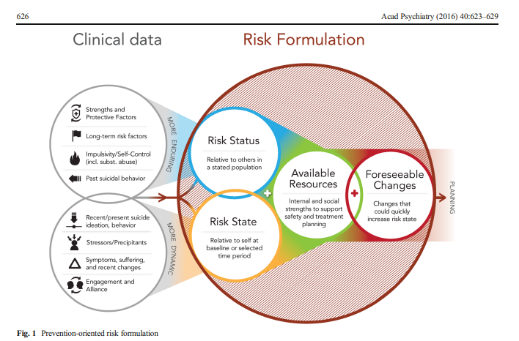

**Mental Health and Risk Formulation:**

(A summary of the individuals mental and risk assessment in a succinct clear paragraph).

**Linking Theory to Practice** (using appropriate literature, reference, and research the following to show the process of linking theory to practice with your chosen client)

Provide the following information in relation to your client.

Include:

1. A brief overview of diagnosis, (referenced) and how this relates to your client.

1. Psychiatric medications include the following and how they relate to your client:

mechanism of action, indications for use side effects, contraindications, nursing responsibilities and client education.

**References:**

Durie, M 1994, *Whaiora: Māori health development,* 2nd edn, Oxford University Press New Zealand: Oxford, UK.

Pisani, A.R., Murrie, D. C., & Silverman, M. M. 2016. Reformulating Suicide Risk Formulation: From Prediction to Prevention. *Acad Psychiatry 40:*623-629. DOI 10.1007/s40596-015-0434-6.

University of Columbia. 2009. *Columbia-Suicide Severity Rating Scale (C-SSRS)*.

University of Adelaide. 2023. *ASSIST Lite: Alcohol, Smoking and Substance Involvement Screening Test.*