Clinical Reasoning Cycle: the nursing process
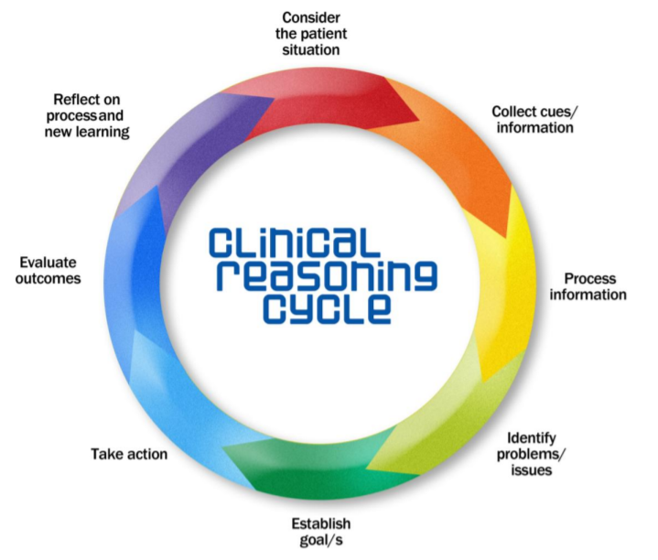

BN702002 Acute Care 3
https://www.utas.edu.au/__data/assets/pdf_file/0003/263487/Clinical-Reasoning-Instructor-Resources.pdf

This part of the clinical reasoning cycle involves a head to toe assessment. It ensures that you consider the patient situation, that you collect cues and information, and begin to process that information.

Safety and environmental risk check: Introduce self/obtain informed consent, perform hand hygiene,

correct patient identification, make eye contact, ask appropriate interview questions.
Consider use of non-identifiable information in your portfolio submission
Medical Diagnosis on Admission:
Describe in-depth, the pathophysiology of your chosen patient’s medical diagnosis. Include relevant investigations and treatments. Make links to your other theory courses such as bioscience. Feel free to include photos, diagrams etc

Health History
Biographical Data: Age, gender, ethnicity, occupation

Reason for admission

History of present health concern

Past Health History
Allergies and sensitivities
Multidisciplinary team input

Family Health History

Lifestyle
Smoking, Alcohol, Immunisation, Contact communicable disease, Family Violence

Social (based on Te Whare Tapa Wha)
Taha whanau – family and social well-being
Do you feel comfortable talking about your whanau/family? Who are the people that support you day to day, everyday life? Will they be there for you on discharge? If you were going to describe your family/whanau, who would they be? Home environment – who lives at home with you? Are you currently working? If so, will your workplace support you in your recovery?
Taha wairua – spiritual well-being
Are there any particular beliefs, cultural practices, a religion, church or group? Tell me what the involvement in the activity/group mean for you? Consider how would this apply within a health context. What would you need to know as the nurse to enable you to work in a culturally safe way?
Taha hinengaro – mental health and emotional well-being
How would you describe yourself? Is there anything that currently concerns you? Tell me about how you manage stress and worry? Who supports you? How do you keep well? Are there certain situations which can make you anxious? How have you felt about your previous experiences with health? Do you have any hobbies? What are your leisure activities
Taha tinana – physical well-being
Consider each system: Inspect, Auscultate, Percuss, Palpate
General Survey
- Level of consciousness
- Skin condition and colour, personal hygiene
- Speech – articulation, pattern, content appropriate
- Facial Expression
- Behaviour Body language, affect
- Posture and Gait
- Physical Development and body build
- Gender and Sexual development
Measurement
- TPR BP SPO2 Weight Height BMI Fluid balance BGL
- COLDSPA pain assessment and management, pain medications? Utilise appropriate assessment tool to evaluate pain status e.g., numeric rating scale, Wong Baker scale
Neurological and Musculoskeletal assessment
- Orientated to time, place, person
- Headache Dizziness
- Communication Behaviour, Speech, Mood
- Mobility/Motor strength tremors, weakness, numbness, tingling, coordination
- Management of ADL’s
- Falls risk assessment tool
If indicated: Glasgow coma scale
Respiratory Assessment (ventilation and oxygenation)
- Respiratory Rate, pattern, WOB, symmetry, expansion, accessory muscles
- Cough– and deep breathe - any mucous, sputum, secretions, orthopnoea, haemoptysis
- Oxygen therapy (check charting and fitting of mask, nasal prongs)
- Auscultate anterior/posterior lung fields
Cardiovascular Assessment/Peripheral vascular (circulation and perfusion)
- General appearance, skin colour, central cyanosis, temp, moisture
- Auscultate rhythm at apex – s1 s2, regular or irregular?
- Radial pulse regular or irregular?
- Any chest pain?
- Check capillary refill, CWMS, palpate dorsalis pedis pulses, posterior tibial pulses, popliteal pulses Clubbing?
- Peripheral oedema
- Oral or IV fluids
- Central or peripheral access, tubing and site dated
Skin, hair and nails assessment
- Skin: colour, temperature, turgor, rashes, lesions,
- Wounds, drains and invasive sites, last dressed? Dated? Marked? Any signs and symptoms of infection; skin breakdown
If Pressure ulcer risk if indicated: use the Braden scale or Waterlow skin risk assessment tool
GI and abdominal assessment
- Appetite, nausea, vomiting, anti-emetics Dysphagia
- Nutrition assessment
- Nasogastric tubes, ostomy contents, tube feed if relevant
- Bowel pattern, any changes or concerns, Bristol Stool Chart in use?
- Abdomen: symmetry, contour, soft or firm, any scars or abnormality.
- Enquire if passing flatus,
- Auscultate bowel sounds
Urinary assessment
- Enquire if voiding regularly
- Pain or burning on micturition
- IDC insitu?
- Check urine: amount and colour, odour
Charted Orders
Relevant investigations patient has had or is waiting for:
e.g. bloods: BSL, coags, U & E, FBC, ECG, x-rays, scans
Current medications | dosage | indication for use |  | side effects | nursing considerations for administration

This part of the process is ensuring that you continue to follow the clinical reasoning cycle by identifying problems, establishing goals, outlining what your action will be, the rationale for the intervention and evaluating those actions.

Identifying health problems / issue | Establish the goal | Take action  (What interventions can you do to achieve the goal?) | Rationale  (Why have you chosen the interventions?) | Evaluation of Objective  (new learning and possible different approach)

This part of the process is ensuring that you address the next part of the clinical reasoning cycle by reflecting on the care that you gave

Reflect on process and new learning

