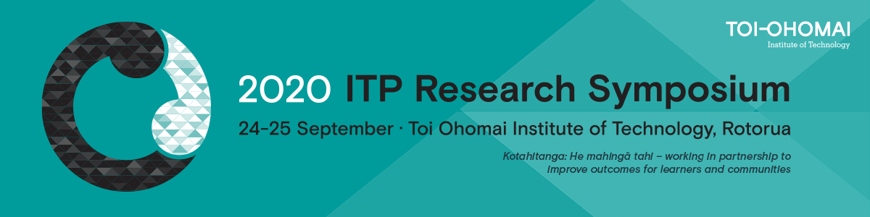

ITP RESEARCH SYMPOSIUM 2020 ABSTRACT SUBMISSION FORM

Kotahitanga: He mahingā tahi
Working in partnership to improve outcomes for learners and communities

The conference theme encompasses the many, varied and mutually beneficial partnerships that exist between ITPs and our stakeholders and partners that lead to improved outcomes for learners and hāpori (communities), including those yet to be realised with the establishment of NZIST.

The conference subthemes are:
- Co-creating research outcomes with hapu, iwi and hāpori
- Adaptive systems for enhanced industry and learner outcomes (e.g. employability, internships and work-based learning)
- Embracing disequilibrium (e.g. innovative models and contributions to our future organisation and partnerships, including alternative ways of measuring learner success)

Please submit your 250 word abstract using the form below BEFORE or on Friday 24 July.

Your abstract will be assessed against the following criteria:
- Relevance to the conference theme or one of the sub-themes
- Collaboration/partnership with others demonstrated
- Applied research that demonstrates valued outcomes to stakeholders

Email Address
Presenter/s name
Presenter/s bio
Institution affiliation
Partner/collaborator name/s and affiliation
Abstract title
Abstract (250 words)
Presentation type:
- Presentation (20 mins)
- Student Snapshot (10 mins)
- Poster

